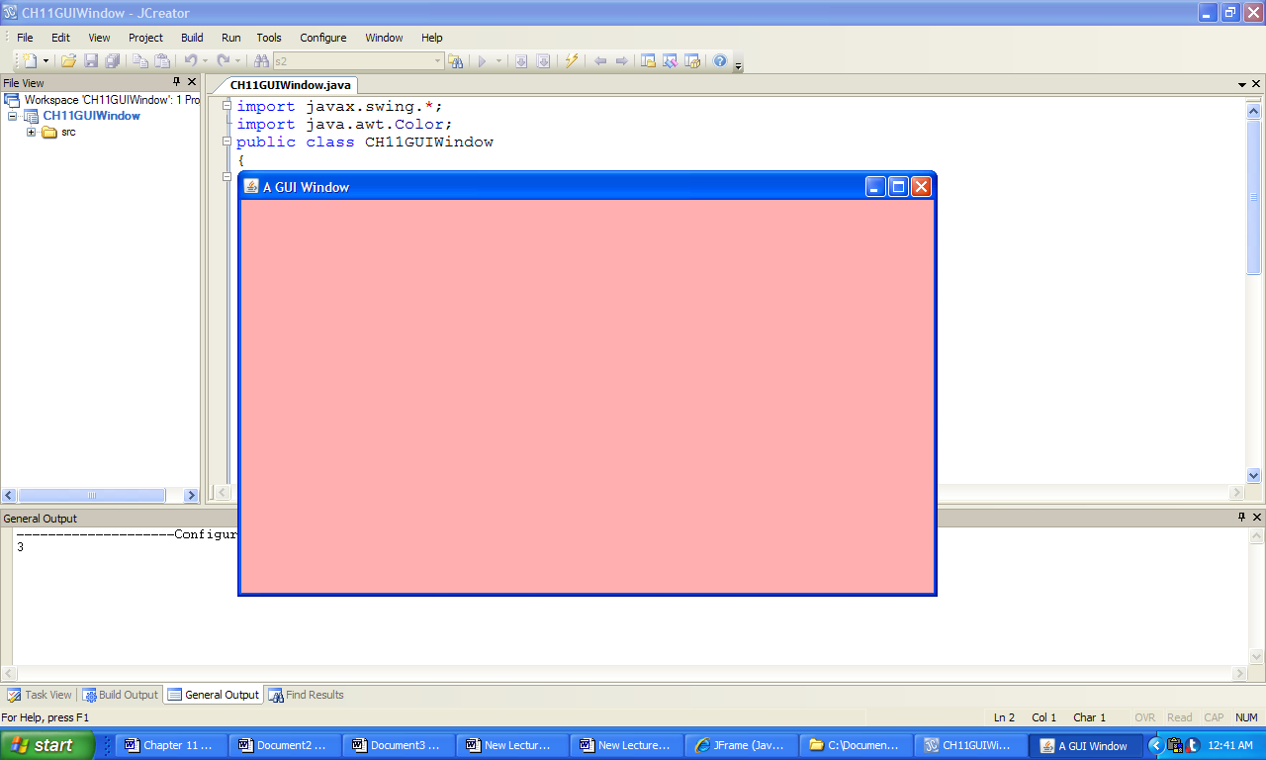

**Figure 11.10 The window produced by the application GUIWindow.**